LEGISLATIVE NEWSLETTER WEEK 9

Legislature Working on Property Tax Relief Bill
On Monday, the House voted 48-13 to send House Bill 690 to the Senate for its consideration. The bill, sponsored by Representative Jason Monks (R-Meridian), would establish the County and City Property Tax Relief Fund and provide property tax relief to property owners in Idaho through a surplus eliminator. When Idaho has a surplus and more tax revenue collected than is allocated to state budgets, up to $80M can be transferred into the County and City Property Tax Relief fund. The money would be distributed with 50% going to each of Idaho’s 44 counties and 50% to each of Idaho’s cities, using the Idaho State Tax Commission's allocation proportions. The bill has been transmitted to the Senate to be heard in the Local Government and Taxation Committee.

Last week, another bill to provide property tax relief, House Bill 709, was printed and referred to the House Revenue and Taxation Committee. The bill amends an existing bill and changes the revenue-sharing arrangement of sales tax collections between Cities, Counties, and local taxing districts to include online sales tax collections. The legislation would distribute 12% of online sales tax collections equally between Idaho cities and counties and require that no less than half of the money is used to provide property tax relief. It is estimated that Idaho property taxpayers will see a reduction in their property taxes equal to 5.75% of all online sales tax collections. In 2024, online sales tax collections are estimated to be approximately $40M. Under this proposed legislation, Idaho taxpayers would see $2.3M in property tax relief. The bill has not yet been heard in committee.

Pushing Back on Neighboring Blue States Trying to Gouge Idaho Businesses and Consumers

Last week the Senate passed House Joint Memorial 5 (HJM5) to push back on a Washington State effort to impose $.06 per gallon tax on all types of fuel headed to Idaho. This export tax would have been added to the cost of fuel that is refined in or transits Washington. Much of our fuel comes from Washington seaports. This proposal would cost Idahoans more at the pump, increase costs and impact agriculture, construction, mining, and other industries. The Joint Memorial passed unanimously and was sent to the State of Washington, where their legislature has since dropped the proposed legislation.

House Bill 677 responds to an effort by the Oregon Department of Revenue to impose taxes on Idaho businesses. This means that Oregon could impose a tax on a business within Idaho’s boundaries selling an item to an Oregon resident who is physically present in the state of Idaho during the time of the sale. House Bill 677 would protect Idaho citizens from this overreach by prohibiting the enforcement of specific taxation of Idaho businesses by out-of-state taxing entities. The bill passed the House 61-0-9 and has been referred to Senate Local Government & Taxation.

Senate Passes Bill to Require Legislature to Adjourn by the end of March
On Monday, the Senate passed Senate Bill 1239a, which would require the legislature to adjourn sine die by the last Friday in March. The bills, sponsored by Senator Jim Guthrie (R-McCammon) provides for exceptions; for example, the legislature would be able to stay in session in cases of declared statewide emergency, when waiting to act on a gubernatorial veto, or when the requirement is overridden by passage of a concurrent resolution. Senator Guthrie said, “My hope if it would pass, (is) that we would work diligently and sine die consistently before that date. It provides an expectation for our citizen legislators and our citizens.” Senate Pro-Tem Chuck Winder (R-Boise) thanked Senator Guthrie for his “continued diligence.” The bill passed 28-6 and will be heard in the House State Affairs committee.

Bill Supporting All-day Kindergarten Option for School Districts Moves Forward
On Thursday, the Senate Education committee sent Senate Bill 1373 to the full Senate with a do-pass recommendation. The bill’s co-sponsors, Senators Steve Thayn (R-Emmett) and Carl Crabtree (R-Grangeville), worked with fellow committee members and education leaders to find a solution that gives schools districts the flexibility to offer full-day kindergarten should they want to. The bill gives school districts the option to use state literacy intervention funding for optional full-day kindergarten classes. It also introduces a new funding formula that rewards schools that help students maintain proficiency or improve reading skills. The full Senate will consider the bill, and if passed it will be sent to the House for consideration.

“Protecting Free Speech in Higher Education Act” Passes the House
The “Protecting Free Speech in Higher Education Act” was passed by the house (63-2-5) to add further protection of free speech in higher education. Specifically, the bill will protect First Amendment rights to free speech in outdoor areas as defined in the bill’s statement of purpose. Some have expressed worries that it takes away established protections that universities have been granted to preserve the learning environment, such as preventing speech that may be deemed harmful to students. This bill could change that but will still allow public institutions to maintain and enforce reasonable time, place, and manner restrictions on public speech. The bill’s sponsor, Rep Ehardt, said that she found four freedom of speech complaints while drafting HB 684. The bill states that a significant amount of tax dollars are allocated to public institutions of higher education; therefore, freedom of speech should be recognized in institutions receiving state funds.

Governor Establishes Operation Esto Perpetua to Fight Illegal Drug Trafficking in Idaho
On March 3, Governor Little announced a new initiative, Operation Esto Perpetua, to combat drug trafficking in Idaho. The initiative establishes a law enforcement working group and a citizens working group. That group includes Senator Abby Lee (R-Fruitland) and House Speaker Scott Bedke (R-Oakley), along with representatives from the Shoshone-Paiute Tribe, mayors, and county commissioners. The group is tasked with traveling throughout the state to meet with members of law enforcement and the public. They will present their findings and recommendations for prevention, treatment, and enforcement to the Governor. The group will begin traveling the state on March 14th. More information on the initiative can be found on the Governor’s website here.

Empowering Parent Grants Bill Signed by Governor Little
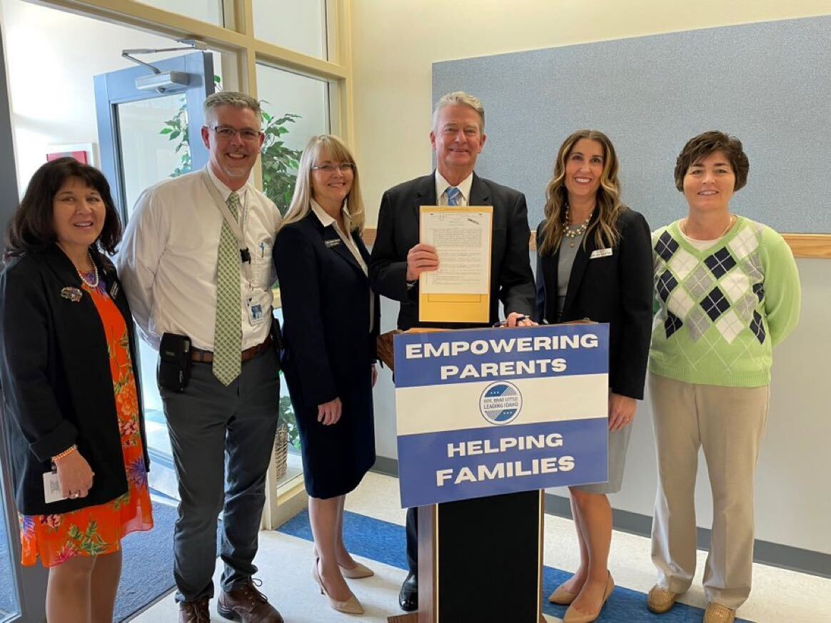
On Tuesday, March 1, Governor Little signed Senate Bill 1255 into law putting $50 million toward the new “Empowering Parents” grants. Gov. Little stated, “The Empowering Parents grants reinforce this fact – a person’s education starts in the home. Parents are in the driver’s seat, as they should be and always will be in Idaho. The Empowering Parents grants put families in control of their child’s education and helps set them up for success.” Governor Little added that, “the Empowering Parents grants were a key part of my ‘Leading Idaho’ plan, and I appreciate my legislative partners for making it a priority, especially the bill’s sponsors, Senator Lori Den Hartog and Representative Wendy Horman. The children today will become the workforce of tomorrow. We want our Idaho students to receive a strong foundation of learning now so they can stay here and make our state prosperous for future generations.”

Idaho Senate Celebrates Governor Phil Batt on his 95th Birthday
Philip Eugene Batt was born 95 years ago in Wilder, Idaho on March 4th, fittingly on Idaho Day. Batt was an onion and hops farmer from Wilder. He served in Republican politics for more than 30 years, serving in the House, Senate and as Lt. Gov. After rebuilding the Idaho Republican Party into near-total dominance as party chairman in the early 1990s, Batt reentered electoral politics. In 1994, Batt won his race for Idaho Governor and served until 1999. Despite polls putting his popularity at around 80%, he chose to serve only one term. Batt's more notable accomplishments as governor were pushing through worker’s compensation for agricultural Workers and negotiating a pact limiting nuclear waste storage in Idaho. During his term, Idaho’s cabinet had a higher percentage of women than any other state.

Opportunity for Idaho Students to Learn from NASA
Idaho Science and Aerospace Scholars is a competitive program that allows high school juniors to take an engaging online NASA-developed course on Space Exploration through Idaho Digital Learning. It teaches a broad range of Science, Technology, Engineering, and Mathematics (STEM) skills aligned with Idaho Content Standards. To apply to become an Idaho Science and Aerospace Scholar, students must be a U.S. Citizen and Idaho resident, be a high school junior with interest in science, technology, engineering, or mathematics, have a minimum GPA of 2.7. If you know of any interested students, they can access more information and the application here.

Governor Little Announces He’ll End COVID-19 Emergency Declaration

After weeks of thoughtful deliberation with stakeholders, Governor Little announced that he plans to end Idaho’s declared state of emergency for the COVID-19 pandemic on April 15th. Throughout the pandemic, Idaho has remained open, never mandated masks or vaccinations, banned vaccine passports and challenged President Biden's vaccine mandates in court.

A Quick Update on JFAC

The Joint Finance-Appropriations Committee has approved the K-12 education budgets with unanimous or nearly unanimous votes. The budget bills will now go to the House and Senate to vote on, but here are some of the highlights:
• $74 million into school nutrition programs
• $46.7 million into early literacy programs
• $103.6 million for teacher pay raises
• $36.7 million for educator and classified staff bonuses
• $180.9 million for health benefits

Idaho By the Numbers
Idaho’s information technology sector has grown substantially in recent years and Idaho is the fastest-growing state in the nation for IT jobs. Here’s a look at the industry’s contribution to Idaho’s economy.

Quick Facts about Idaho’s Technology Industry

Economic impact | $7.2B | Economic impacts as % of overall | 9.5%
Net tech employment | 53,803 | Net employment as % of workforce | 6.6%
Tech business establishments | 3,864 | Median wage | $71,070

Bill Tracker (will be updated Friday before distribution)

SB 1226 This legislation declares that Idaho students can be designated as self-directed learners if they meet the criteria laid out in the bill. Introduced, printed and referred to Senate Education.

S1228 Repeals existing law relating to enclosures of reservoirs and dumps. Passed the Senate 35-0 and referred to House Resources and Conservation

SB 1241 This bill makes a change to Idaho Code by increasing the maximum value of a home that qualifies for the property tax reduction program (aka Circuit Breaker) to assist more low-income applicants to remain in their homes. Reported out of Senate Local Government & Taxation with a do-pass recommendation. On the Senate Second Reading Calendar.

SB 1249 This bill corrects an error in last year's H 389 so that expiring Urban Renewal Districts come into local property tax budgets at eighty percent not subject to the eight percent cap. It also closes an unintended loophole regarding the use of foregone balances in property tax budgets. Reported out of Senate Local Government & Taxation with a do-pass recommendation. Passed the Senate 34-0-1 and referred to House Revenue and Taxation.

S1254 Amends, repeals, and adds to existing law to remove certain provisions regarding air quality related to motor vehicles and to provide revised provisions regarding air quality programs. Reported out without recommendation as amended. Amendments ordered printed, referred for engrossment.

SB 1255 This bill creates The Empowering Parents Grant Program which will provide funding to parents to help meet their child’s educational needs and to address any learning loss with grants of $1,000 per student or a maximum of $3,000 per family for public and non-public students. Delivered to the Governor.

SB 1262 This legislation enhances the protections for firearms, ammunition, and components during a declared disaster emergency. Delivered to the Governor.

S1264 Amends existing law to revise legislative findings and to revise provisions regarding rescission. Filed for Third Reading.

1267

S1280 This bill would define dyslexia in Idaho code and recognize the unique influence and challenges students with characteristics of dyslexia face in developing their reading and literacy skills. The bill would require that school districts and charter schools assess students in kindergarten through fifth grade for characteristics of dyslexia so plans for specific interventions can be identified and offered. Passed the Senate 33-0-2 and referred to House Education.

S1287 Adds to existing law to establish the rural nursing loan repayment program. Failed 14-17-4.

S1291 Amends existing law to provide alternative methods of obtaining certain certifications. Reported out without recommendation as amended. Amendments ordered printed, referred for engrossment.

SB 1239 This bill would require the legislative session to end on or before the last Friday in March each year unless two-thirds of each house votes to go longer. A similar bill was introduced last year, but died in the house. Introduced, printed and referred to Senate State Affairs.

S 1311 Adds to existing law to designate the Idaho cut as the official state cut of Idaho for faceted gemstones. Filed for Third Reading.

S 1319 This bill amends contracts regarding school transportation services. Reported out of Committee with Do Pass Recommendation. Read a second and third time.

S 1321 Amends existing law regarding assault or battery upon employees of a public or consumer-owned utility. Filed for Third Reading.

S 1324 Amends existing law to remove provisions regarding sexual abuse and sexual battery of certain minors. Filed for Third Reading.

S 1332

S 1333 Amends existing law to revise the number of judges in the Fourth Judicial District and to revise provisions regarding resident chambers. Filed for Third Reading.

S 1337
S 1342 Amends existing law to provide an exemption from a certain requirement and to provide a requirement for a license issued to a theater.

S 1345 Amends existing law to revise provisions regarding the careless exposure of barbed wire and to revise penalties. Referred to Agricultural Affairs.

SCR 115
SCR 117
SCR 119

HCR 29 States findings of the Legislature and encourages certain officers, agencies, and employees of the State to become informed about the impacts of traumatic childhood experiences and to implement interventions and practices to develop resilience in children and adults who have suffered from traumatic childhood experiences.

HB 436 Income tax rebate; reduces independent and corporate income tax rate. House passed 57-13; Passed Senate 27-7-1. Signed by the Governor on February 4, 2022.

HB 441 This bill offers absentee ballot assistance for those in nursing care facilities by designating three authorized sources of voter assistance. Referred to House State Affairs.

HB 443 This proposed legislation will create a dedicated fund to bring school district employees’ healthcare coverage up to the same standard as that of state employees. The bill passed the House 55-14, the Senate 32-3 and was signed by the Governor.

HB 444 Amends 2021 session law to extend a sunset date to July 1, 2023.

HB 450 This proposed legislation will provide employers with unemployment insurance tax rate stability and consistency by extending the 2021 unemployment insurance base tax rate over a period of two years. This will result in a tax savings of $64 million for Idaho businesses over the next two years. Reported Signed by Governor on February 18, 2022.

HB 461 This bill aims to update Idaho code 33-4302 so that the child or spouse of a military member who has fallen in combat is eligible for this scholarship, seeing that they meet other prerequisites laid out in the bill. Passed the House 67-0 and filed for a third Senate reading.

HB 469

HB 506 This bill would amend Section 33-4302(7) of Idaho Code to allow the Idaho Division of Veterans Services to determine disability for members of the Armed Forces, instead of the United States Social Security Administration. Passed the House 66-0 and filed for a third Senate reading.

HB 533

HB 559 Adds to existing law to authorize the use of certain archery equipment. Passed the House 63-0-7 and filed for a third Senate reading.

HB 560
HB 598
HB 685
HB 688
HB 703
HB 701

You are receiving this email because you have indicated an interest in legislative activities by emailing your Legislator or signing up for this newsletter. If you would prefer not to receive it in the future, please click the unsubscribe link in the blue box below to be immediately unsubscribed.

